Talking Points for West Nile Virus Pesticide Fogging (Spraying)

- Spraying pesticides suppresses the human immune system, which may increase your risk of contracting West Nile Virus (WNV) and COVID-19.

- West Nile Virus is NOT A THREAT TO 99.99% of people, and NOTHING needs to be done about it. People have a greater chance of being struck by lightning than dying of the West Nile Virus.

- According to Vector Control’s website, no human cases of West Nile Virus have been reported in Santa Clara County.

- Pesticides are NOT safe. They are designed to be toxic and kill.

- Vector Control claims that pesticides are safe. However, 96% of the ingredients are trade secret. They don’t know what they are. How can they say it is safe?

- After spraying (fogging), hundreds of Santa Clara County residents have reported becoming sick and thousands of local bees have died.

- These pesticides are toxic to humans, impacting all body systems, especially hormonal systems, gut flora, nerve systems, and the brain. Pesticide exposures, including pesticides that have been used by Vector Control, are associated with respiratory illnesses infertility, certain birth defects, and cancer.

- According to Dr. Dennis Good of the Department of Biology at the University of Maryland, he states that pesticides may compromise the blood-brain barrier, thus increasing the risk of encephalopathy (infection of the brain). According to Dr. Good, “In general, West Nile Virus is a mild disease. It only becomes serious encephalitis if the virus can cross the blood-brain barrier. Among the agents that impair the blood-brain barrier in young rats are pyrethroid, organophosphate, and organochlorine pesticides. Thus, insecticide spraying has the potential to worsen the process of WNV infection.” These insecticides are used by Vector Control.

- The pesticide Zenivex E4 (active chemical etofenprox), stated in Santa Clara County water permit, has a 4.1-day soil half-life. Yet, Columbia University found the pesticide Zenivex E4 has more than a year of soil half-life. In other words, the pesticide does not dissipate after days, but instead, it takes years to degrade.

- Vector Control is not adhering to the Santa Clara County ordinance, which states spraying pesticides for West Nile Virus should ONLY be used “…as a last resort.”
  - (Ord. No. NS-517.70, updated 2022). Since there is no West Nile Virus emergency, there is no justification for Vector Control to be spraying the environment with toxic pesticides.

- The Harvard study showed that there was no difference in the rate of mosquito reproduction in the communities that used pesticide spraying vs. those that did not use pesticide spraying.

- Once Vector Control sprays your house, your organic garden will no longer be organic.
http://www.healthyalternativestopesticides.com

- Vector Control’s current program is increasing the mosquito population by killing mosquito predators.

- Government agencies such as the Washington DC Department of Health, Nashville Department of Health, and Maine Environmental Policy Institute don’t spray (fog) because scientific studies show that spraying pesticides is not an effective method of mosquito abatement.

- Where is the Environmental Impact Report?

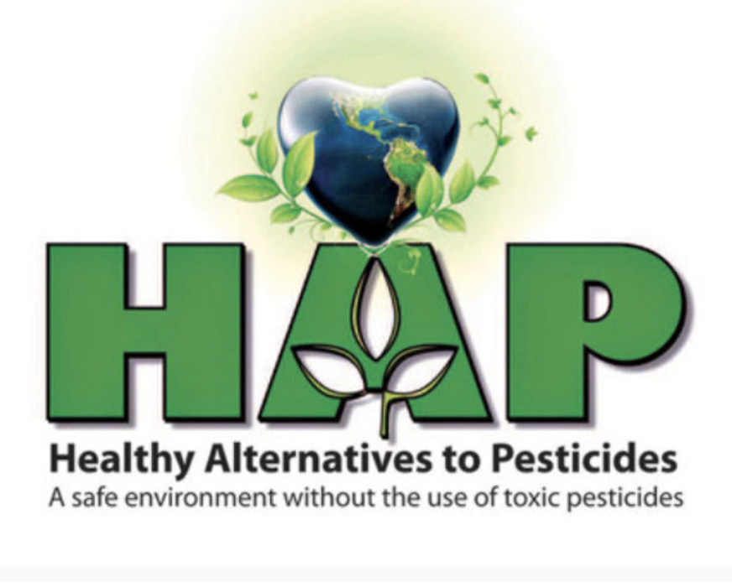
http://www.healthyalternativestopesticides.com

